COMPUTER NETWORKS (CN)

Spring 2024



PROJECT REPORT

Project Title
“Smart City via Cisco Packet Tracer”

Project Contributors
Fizza Rashid (21K-3390)
Sana Khalid (21K-3421)

Submitted to
Sir Kashan Hussain

1) Introduction

A smart city network using Cisco Packet Tracer is a simulated network infrastructure that connects various IoT devices, such as sensors, kiosks, video surveillance cameras, smart lighting, and public Wi-Fi, to improve the quality of life and safety for residents. The network is designed to make cities more efficient, effective, and sustainable by leveraging advanced technologies like IoT, big data, and analytics.
In a smart city network, various components work together to provide a range of services, including air quality monitoring, smart lighting, intelligent transportation systems, public safety, and waste management. The network is built using a robust and secure infrastructure, with a focus on scalability, flexibility, and reliability.
Why Cisco?
Cisco Packet Tracer is a powerful tool that allows users to design, configure, and simulate complex networks, including smart city networks. Moreover, By using Cisco Packet Tracer, users can create a virtual network that mimics real-world scenarios, test different network topologies and configurations, and optimize network performance.
Strategy we followed:
(Packet Tracer Simulation)
- Design: Design the smart city network using Cisco Packet Tracer, including the core, distribution, and access networks.
- Configure: Configure the IoT devices, routers, switches, and access points to simulate real-world scenarios.
- Test: Test the network to ensure that it is secure, efficient, and effective in improving the quality of life and safety for residents.

2) Methodology (including coding/configuration commands)
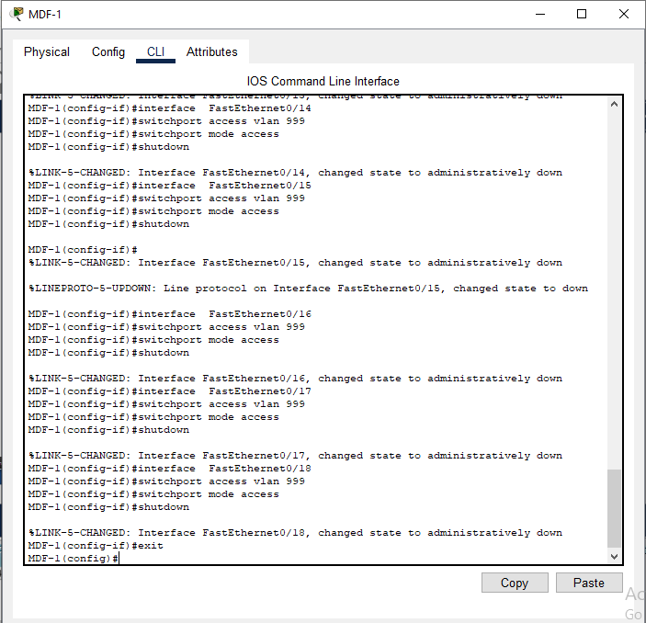
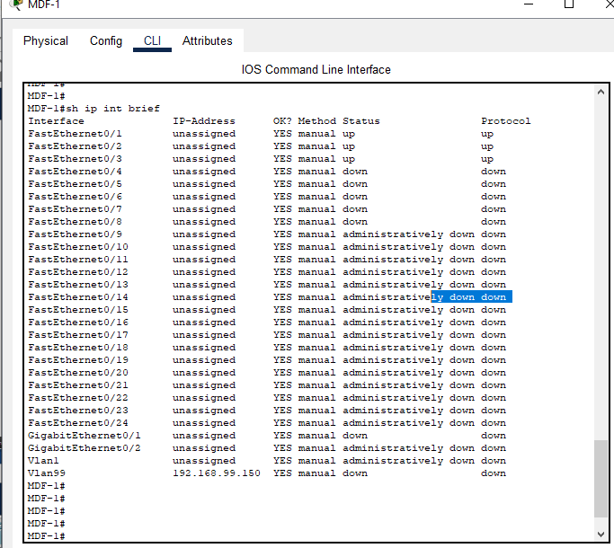
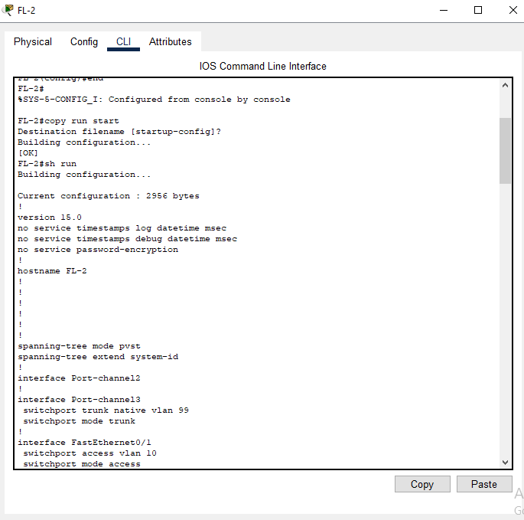

3) output (snap shot or output in any visible form of the proposed output)

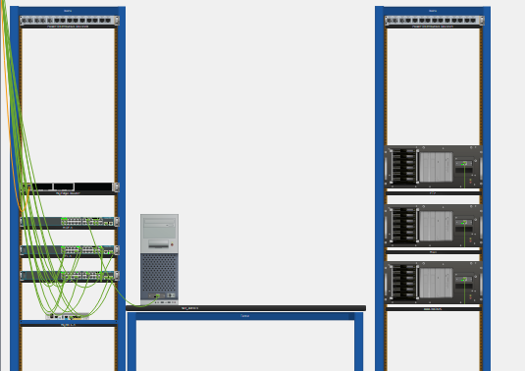
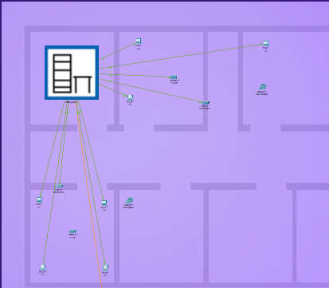

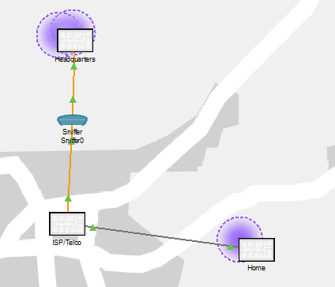

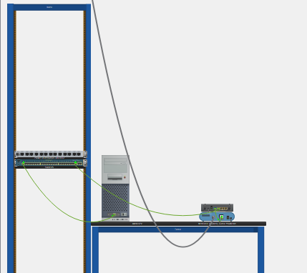
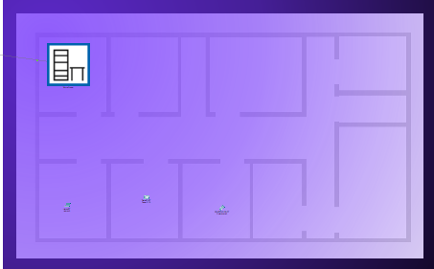
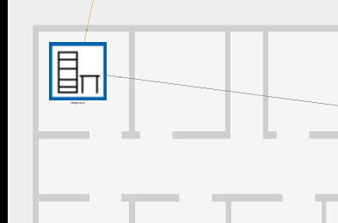
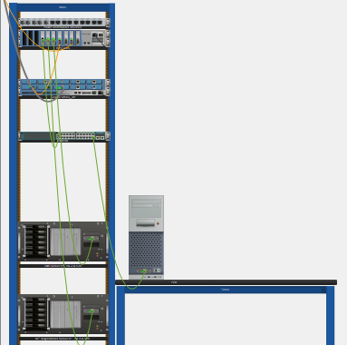

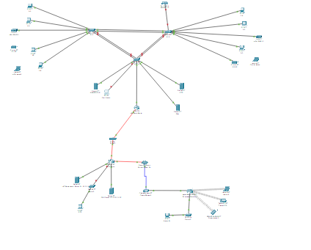

4) References

https://www.researchgate.net/publication/360975345_Smart_City_using_IOT_simulation_design_in_Cisco_Packet_Tracer
https://csitcp.org/abstract/13/1313csit26
https://www.ijraset.com/research-paper/smart-city-using-iot-simulation-design-in-cisco-packet-tracer
https://www.cisco.com/c/en/us/solutions/design-zone/industries/smart-cities-connected-communities.html

